My Erosion Project

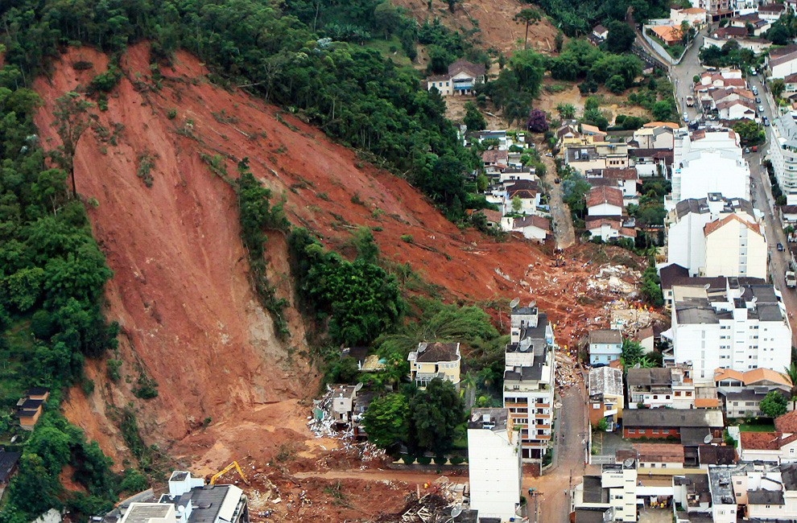

Name _______________

Look at the map below and circle the houses you think are most at risk from a landslide.

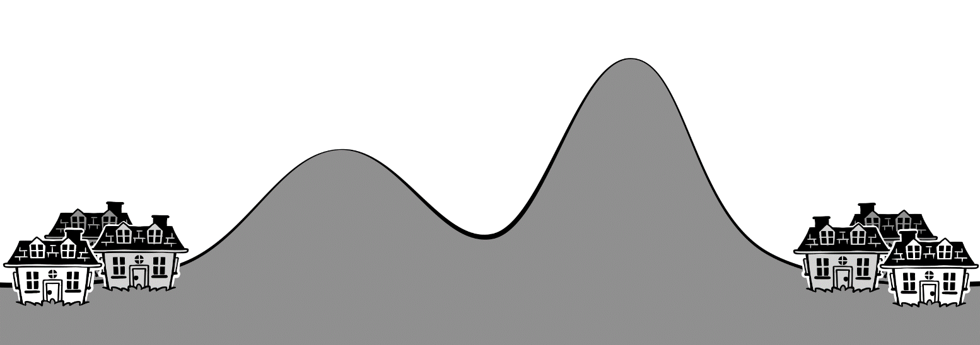

Why did you circle the houses? Use evidence from the map to explain.

______________________________________________________________________________
______________________________________________________________________________
______________________________________________________________________________
______________________________________________________________________________
______________________________________________________________________________
______________________________________________________________________________

Engineers to the Rescue!

Mylo, Suzi, and Angelina were doing homework together and listening to the radio when they were suddenly interrupted by a loud noise.

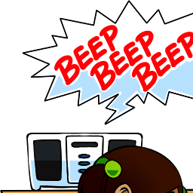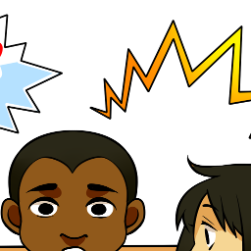
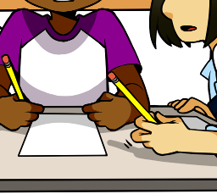

“This is an announcement from the local weather service.
The following counties are under a flash flood warning as heavy rain is expected in the area through 9:00 am tomorrow morning.
*Rolling Hills County
*Forest County
*Creek County”
“Oh no!” said Mylo, “My aunt lives in Rolling Hills County, and her house is at the bottom of a large hill!”
“Why is that a problem?” asked Suzi.
“They had a fire on that hill about a year ago,” answered Mylo.
“I remember,” said Angelina. “But I thought you said your aunt’s house was fine and the fire didn’t damage it.”
“When I visited her last summer she was telling me that the wild fire on the hill above her house made that entire area unstable.”
“The land on the hill behind her house used to be covered in trees and bushes,” Mylo continued, “but since the fire it’s now covered with ashes and burnt tree stumps.”
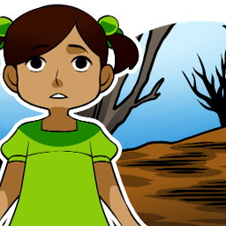
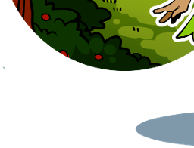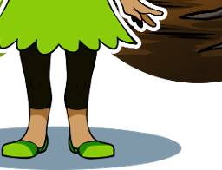

BEEP! BEEP! BEEP!

“This is an announcement from the local weather service.
Residents in the Hillside neighborhood are being asked to prepare for a possible landslide.”
“Oh no!” exclaimed Mylo as he listened to the radio announcement. “That’s my aunt’s neighborhood. I told you I was nervous about that big hill behind her house! I wish there was something we could do to protect her house.”
“There is always something we can do,” offered Suzi. “We just need to use the design process.”
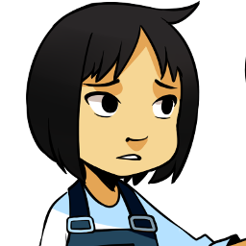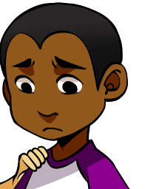
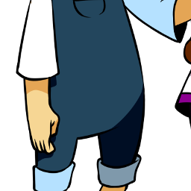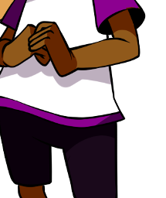
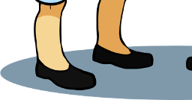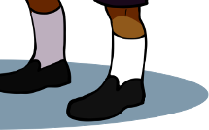
“I don’t think I am even sure of what the problem is,” said Angelina.
“That’s okay; the first step of the design process is to ask ourselves, What is the problem?” offered Suzi.
“The problem is that rain is coming!” said Mylo
“No, that is not the whole problem,” suggested Angelina.

Fully describe the problem below.
________________________________________________________________________________________________________________________________________________________________________________________________________________________________________________

What information would help you solve the problem?
________________________________________________________________________________________________________________________________________________________________________________________________________________________________________________

Research notes:

Experiment
List 3 supplies that you want to try

Testing:

- Arrange the sand on the ramp like your teacher’s picture

- Pour 500mL of water on at the top of the ramp

- Scoop up the sand that eroded “below” the line. Put it in your graduated cylinder to see how much there is.

Results for each material

Materials | Results – How much sand eroded?

Brainstorm
List your ideas here

Sketch your ideas here

Choose one Solution to Build
Detailed drawing of our solution

We are choosing to build this solution because

Testing

- Arrange the sand on the ramp like your teacher’s picture

- Arrange the houses at the bottom of the sand like your teacher’s picture

- Pour 500mL of water on at the top of the ramp

- Scoop up the sand that eroded “below” the line. Put it in your graduated cylinder to see how much there is.

Milliliters (ml) of sand eroded: | Observations of erosion:

Evaluate solutions

Explain one strength of your design
________________________________________________________________________________________________________________________________________________________________________________________________________________________________________________

Explain one weakness of your design
________________________________________________________________________________________________________________________________________________________________________________________________________________________________________________

Did your design fully solve the problem? Why or why not?
________________________________________________________________________________________________________________________________________________________________________________________________________________________________________________

Revise design

How would you change your design?
________________________________________________________________________________________________________________________________________________________________________________________________________________________________________________

How would these changes improve your design?
________________________________________________________________________________________________________________________________________________________________________________________________________________________________________________

Detailed drawing of your new design

Re-Testing

- Arrange the sand on the ramp like your teacher’s picture

- Arrange the houses at the bottom of the sand like your teacher’s picture

- Pour 500mL of water on at the top of the ramp

- Scoop up the sand that eroded “below” the line. Put it in your graduated cylinder to see how much there is.

Milliliters (ml) of sand eroded: | Observations of erosion:

Did your changes improve the design? Why or why not?
________________________________________________________________________________________________________________________________________________________________________________________________

