Making PLTW Accessible to All Students

PART A:
PLTW’s kindergarten unit on structure and function has the following engineering challenges.
- Build the highest “beanstalk” you can with 10 green pipe cleaners
- Get your “beanstalk” to hold a plastic egg as high as you can off the ground
- Build a house to protect a little pig from a wolf’s blowing (given straw, sticks and bricks)
- Design a paint brush (given a whole variety of craft supplies)
What would students need to understand in order to do these challenges effectively and talk about the design choices they are making?

Take-away from PART A

PART B:
Explain how rivers and lakes are different. Explain what causes that difference.

Take-away from PART B

Bodies of Water Name ___________________
Draw a model of how water moves on hills and in valleys.

Labels: Stream, River, Pond, Lake

Describe how water moves on hills and in valleys.
__________________________________________________________________________________________________________________________________________________________________________________________________________________________________________________________________________________________________________________________________

Name:________________________
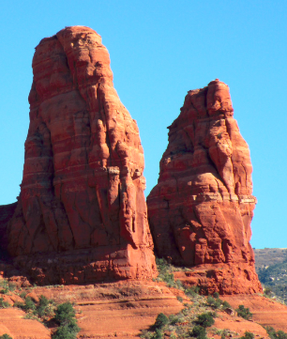
How will wind erosion shape these rocks?

________________________________________________________________________________________________________________________________________________________________________________________________________________________________________________________________________________________________________________________________________________________________________________________________________________________________________________________________________________________________________________________________________________________________________________________________________

PART C:
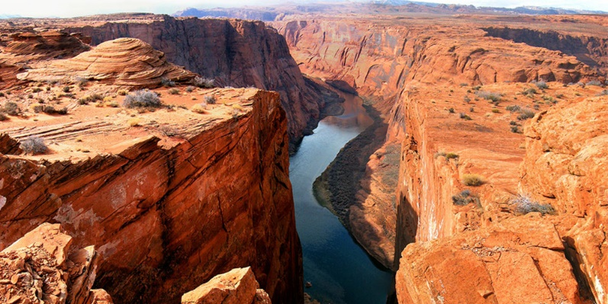

Explain how this landform got created.

Take-away from PART C

Name:________________________
How was this canyon created?

________________________________________________________________________________________________________________________________________________________________________________________________________________________________________________________________________________________________________________________________________________________________________________________________________________________________________________________________________________________________________________________________________________________________________________________________________

Name ______________

How did erosion change the shape of the land?

Picture # _____

Before
________________________________________________________________________________________________________________________________________________________________________________________________________

During
________________________________________________________________________________________________________________________________________________________________________________________________________

After
________________________________________________________________________________________________________________________________________________________________________________________________________

