Activity 4.0 Not-So Instant Challenge: Automata Design Challenge

Introduction
The Creative Problem Solving Process is a valuable tool for engineers. As a small group of two you develop an understanding of the problem and its definition. Then you will research and generate ideas about the problem. Finally, you would make your first prototype to solve the problem. You utilize the design process and document the process in your engineering notebook.

Equipment

- Engineering notebook
- Pencil
- Tape
- Scissors
- Box Cutter
- (1) nail or screw
- (3) drinking straw
- (3) coffee stirrers
- ¼“ Foam Board
- (3) nuts or washers
- ³/₁₆“ or ¼“ Dowels
- Glue gun and glue sticks
- Shoe Box

- (1) small cardboard box or shoe box
- (3) unsharpened pencils and/or bamboo skewers
- Picture of your 3 favorite cartoon characters (related)

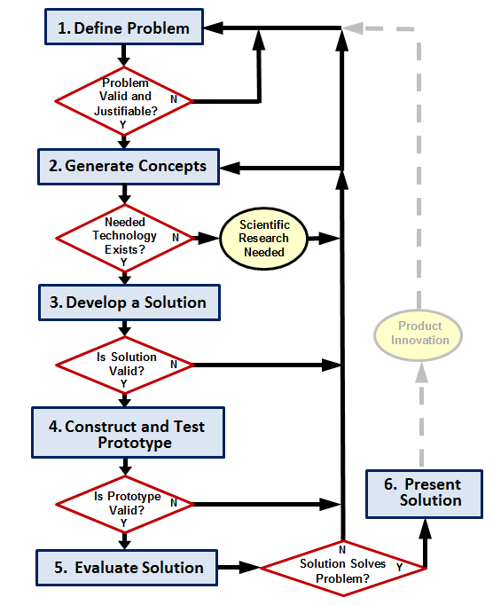

Procedure
- Follow the direction of the teacher while completing this activity.
- Use the design process learned earlier in this lesson. Document each step in your engineering notebook.
- Design a mechanical system that will produce realistic motion of a figure(s) or object(s) resulting from the rotation of an axle that involves the interaction or coordinated movement of at least two separate objects. Design for a child between the ages of 5 and 12 years old.
- The design of the system must have four walls
- The mechanical system must be human powered.
- The system must produce repetitive motion.
- The mechanical system must include at least three cams.
- The system must operate as designed for at least one minute at a sustained speed of one revolution per second without damage to any component of the design.
- The winning design meets the constraints above with three moving carton figures.

Conclusion Questions
- How was research helpful when developing your solution?

- How will developing a prototype improve your next design?

- How does understanding scientific principles help inform you development of solutions for engineering challenges?

